

**LA GRANDEE INTERNATIONAL COLLEGE**

**Simalchaur, Pokhara Nepal**

“Final Report”

On

**“Leo-Futsal”**

(online booking system)

**Submitted to:**

Bachelor of Computer Application (BCA) Program

In partial fulfilment of the requirements for the degree of BCA under

Pokhara University(PU)

**Submitted by:**

|  |  |  |  |
| --- | --- | --- | --- |
| **Name:** | **Course** | **Semester** | **P.U. Registration Number** |
| Kshitij Gurung | BCA | 8th | 2019-01-53-0135 |
| Manish Shrestha | BCA | 8th | 2019-01-53-0120 |
| Kushal Kapri | BCA | 8th | 2019-01-53-0118 |

**Date: 30/06/2024**

# ACKNOWLEDGEMENT

The satisfaction that accompanies after the successful completion of any task will be incomplete without mentioning the people whose ceaseless and relentless cooperation, constant guidance and encouragement made this project possible.

We are grateful to our project supervisor **Mr sunil Sapkota**, and **BCA** coordinator **Mr Ramesh Chalise** for the guidance, inspiration and constructive suggestions that helped us in the preparation of this project.

We are also appreciative among each other and have understood that teamwork, the designation of the task per the skillset one portrays, constant synchronisation and monitoring of progress and instilling new knowledge and skill is imperative for the success of any given work.

Sincerely,

Kshitiz Gurung

Kushal Kapri

Manish Shrestha

**DECLARATION FOR**

**“Leo-Futsal”**

# STUDENT’S DECLARATION

We hereby declare that we are the only authors of this work and that no sources other than the mentioned here have been used in this. We assure you that the work we present here is unique to ourselves and resemblances to another similar project are purely coincidental.

Kshitij Gurung(PU Exam Roll no): 2019-01-53-0135

Manish shrestha (PU Exam Roll no): 2019-01-53-0120

Kushal kapri (PU Exam Roll no): 2019-01-53-0118

Program: BCA, 6th Semester

Date: 30/06/2024

# SUPERVISOR DECLARATION

I hereby recommend that this project entitled “**Leo-Futsal**” is done under my supervision by **Kshitij Gutung** **,Kushal Kapri, Manish Shrestha** during their 8thSemester in partial fulfilment of the requirements for the degree of **BCA** under **Pokhara University** is completed to my satisfaction and be processed for final evaluation.

____________________________

**Name of the Supervisor**

Date:____ / ____ / ________

# LETTER OF APPROVAL

We certify that we have examined this report entitled “**Leo-Futsal**” and are satisfied with the project defence. It is satisfactory in the scope and qualify as project in partial fulfilment of the requirements for the degree of **BCA** under **Pokhara University.**

|  |  |  |
| --- | --- | --- |
| ____________________  **Supervisor**  Mr. Sunil Sapkota | _______________  **Examiner**  Date:____ / ___/ | ________________________  **Program Coordinator**  Mr. Ramesh Chalise |

# ABSTRACT

The Leo-Futsal will be an online web application based on the principle of providing convenience and service to people. The purpose this system is to facilitate the customers to book futsal field and to search the data of the football fields information and administrators can have facilities to store and update the customer’s information. It is developed to give an efficient system to the Futsal.

In the existing system, customer needs to come to the futsal court to make a booking. However, by using Futsal, they can make the online booking anywhere and anytime. This system is covering online booking for customer and online system for staff. This system is for the customers to booking court and other resources, view court availability via online system. The app will display information of several futsal fields that have registered in the form of location, schedule with its booking list and order procedure so that prospective customers could choose and place their order according to desired field and time.

**Table of Contents**

ACKNOWLEDGEMENT ii

STUDENT’S DECLARATION iii

SUPERVISOR DECLARATION iv

LETTER OF APPROVAL v

ABSTRACT vi

1.INTRODUCTION 1

2.PROBLEM STATEMENT 2

3.OBJECTIVES 3

4.BACKGROUND STUDY: 4

5.Development 5

5.1.1 Development model 5

5.1.2 Gantt chart 6

6. SYSTEM DESIGN 7

6.1. 1 DATA FLOW DIAGRAM 7

7. Requirement document 10

8.testing 12

9.PROJECT RESULT 16

10.future enhancement 17

11.CONCLUSION 18

12. REFRENCES 19

13.ANNEX 20

**TABLE OF FIGURE**

Figure 5.1.1:Agile method………….…….....…………………………5

Figure 61.1:Level 0 DFD.………..….…………………………………6

Figure 6.1.2:Level 1 DFD ………..…….……………………………...6

Figure 6.1.3:Level 1 DFD……………………………………………...6

Figure 10.1:Gantt Chart………...…..…….……………………….….. 5

Figure 7.2.1:flowchart…...….……….…….……………………………#

Figure 7.2.2:flowchart……….….…….……………………………...…#

**Abbrebiation**

|  |  |
| --- | --- |
| PU | POKHARA UNIVERSITY |
| SQL | STRUCTURE QUERY LANGUGE |
| BCA | BACHELOR OF COMPUTER APPLICATION |
| DFD | DATA FLOW DIAGRAM |
| SDLC | SOFTWARE DEVELOPMENT LIFE CYCLE |
| SQL | STRUCTURE QUERY LANGUAGE |
| APP | APPLICATION |

# 1.INTRODUCTION

The project “FUSTAL MANAGEMENT SYSTEM” is totally computerized based software application to maintain day to day transactions. In the Futsal Management System, we have made this system for the futsal management team and their customers for keeping the data in a sorted way. This Futsal Management System main features is to record all the booking time and information of the customer for proper management of the booking of the futsal ground. If one customer books the futsal ground in a specific time and if another customer tries to book the ground at the same time and due to administrator mistakes. The administrator or owner of the futsal ground may book the ground for both the customers at the same time hence resulting in a conflict this is one of many problems futsal management has to face and our Futsal Management System hopes to solve this problem.

As many other futsal courts today still use the manual booking system. This system is quite unfriendly to the user. By using the current system, the management of the futsal ground can easily record all the data of the customer and their booking time in efficient and arranged way. The booking data of the current system will be stored manually and it has a high probability that the data might lose or misplaced. So, this system will store the date into the database of the system which will store the record and can be achieved in the future.

Leo futsal Project Modules:

Here we need totally 2 modules. They are,

1. player/customer

2. Admin

1. Player – players can update their information and search for other player information.

2. Admin – Admin have full access permission who manages and update all the users details, approve user registration to the system.

Front-End : flatter

Back-End : flatter,laravall

Database : MySql

# 2.PROBLEM STATEMENT

There can be several problem statements that led to the development of the futsal management system Platform, some of them are:

1. Data Security: The existing system stores booking data manually, making it susceptible to loss or misplacement. Ensuring the security and integrity of customer data is a significant challenge.
2. Double Booking Issues: There is a high probability of double bookings due to human errors. Administrators may accidentally book the same time slot for multiple customers, leading to conflicts and dissatisfaction.
3. Scalability Issues: As the futsal facility grows, the manual booking system becomes increasingly difficult to manage. A scalable solution is needed to handle an increasing number of bookings and customers efficiently.
4. Inefficient Data Management: Managing booking records and customer information manually is prone to errors and time-consuming. This can lead to mismanagement of bookings, making it difficult to maintain an organized and up-to-date record system.

# 3.OBJECTIVES

Following are the objectives of the leo futsal:

* Dynamic Mobile App: Use Flutter to build a responsive app that prioritizes a seamless user experience for easy futsal court reservations.
* Robust Backend System: Using Laravel, create a dependable backend architecture to effectively manage user reservations, court availability, and vendor interactions.
* Real-Time Updates: Make sure users have accurate information to make well-informed booking selections by providing them with up-to-date information about court availability.
* User-Centric Features: Align the app with the requirements and preferences of the user by introducing amenities selection, team development, and in-app communication.

# 4.BACKGROUND STUDY:

We team had a discussion on which topic to do project. So one of our team member came with the idea of futsal management system. We did research in this topic and found maximum reason to do that since this is our first project selecting complex topic wouldn’t have been good so all of us were in the search of simple topic with a best usability in life. After research we also found that in present digital era is needed in every medium and large business organization.

Developing a futsal management system involves integrating various functionalities to streamline operations and enhance user experience within futsal facilities. Such a project typically includes features like online booking systems for courts, player registration and management, scheduling of matches and tournaments, payment processing, and real-time updates on court availability. The system aims to automate administrative tasks, improve efficiency in managing bookings and payments, and provide players and administrators with a user-friendly interface. Additionally, incorporating analytics for performance tracking and reporting can further optimize facility management and resource allocation. Overall, a well-designed futsal management system enhances operational efficiency, customer satisfaction, and revenue generation for futsal facilities.

The background shows the use of the application is to make people easier for booking futsal field, with this online booking peoples will more effective and efficient for their time to booking futsal field also with the information in blog page, people can manage themselves to always being healthy.

# 5.Development

# 5.1.1 Development model

Agile enables software development teams to stay adaptable.With an iterative and adaptive approach, the aim is to produce the highest-quality software product that puts the customer at the heart of the process. By prioritizing flexibility, Agile teams can quickly react to changes, deliver products faster, and thrive in a collaborative environment.

Agile project management focuses on delivering maximum value against business priorities in the time and budget allowed, especially when the drive to deliver is greater than the risk. Some agile principles include:

* The project breaks a requirement into smaller pieces, which are then prioritised by the team in terms of importance.
* The agile project promotes collaborative working, especially with the customer.
* The agile project reflects, learns and adjusts at regular intervals to ensure that the customer is always satisfied and is provided with outcomes that result in benefits.
* Agile methods integrate planning with execution, allowing an organisation to create a working mindset that helps a team respond effectively to changing requirements.

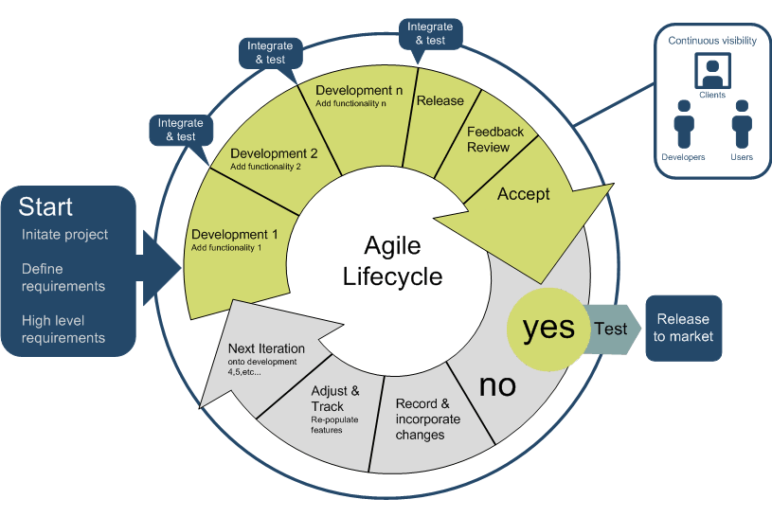.

**Fig: Agile methodology development 5.1.1**

# 5.1.2 Gantt chart

The Gantt chart below shows the schedule planned for developing the “leo futsal” following Agile Model Methodology. Thus, this project would be carried out in steps with proper planning in each step, best effort would be applied to finish this project before deadline.

* A Gantt chart is a visualization that helps in scheduling, managing, and monitoring specific tasks and resources in a project.
* It consists of a list of tasks and bars depicting each task’s progress.
* The horizontal bars of different lengths represent the project timeline, which can include task sequences, duration, and the start and end dates for each task.
* It’s the most widely used chart in project management.
* Gantt charts are used in heavy industries for projects like building dams, bridges, and highways, as well as software development and building out of other goods and services.

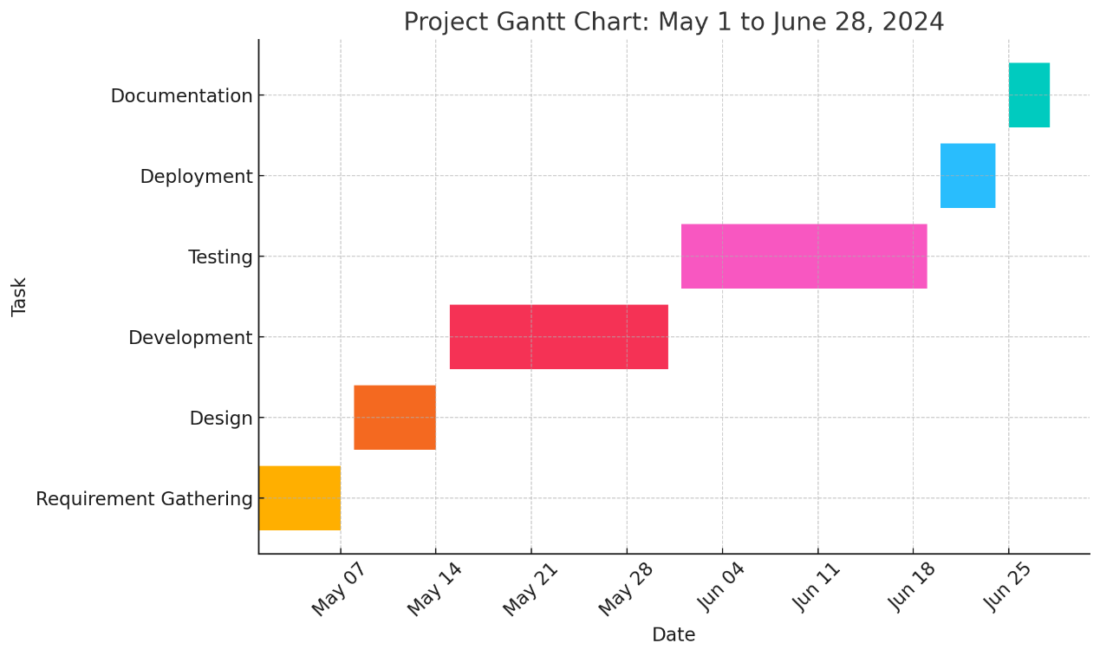

**Fig: Gantt chart 5.1.2**

# 6. SYSTEM DESIGN

# 6.1. 1 DATA FLOW DIAGRAM

DFD stands for Data Flow Diagram, which is a graphical representation of a system or process that shows the flow of data between different components of the system. It is a useful tool for analyzing and designing complex systems, and it can help to identify potential problems and inefficiencies in a system.

The Data Flow Diagram (DFD) outlines the flow of information within the system.

Level Description

|  |  |
| --- | --- |
| 0 | Context Diagram showing the interaction between users and the system. |
| 1 | Detailed DFD showing processes like user registration, booking, and payment processing |

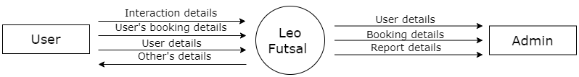

**Figure6.1.1:- level 0 DFD**

**6.1. 2 Dataflow diagram**

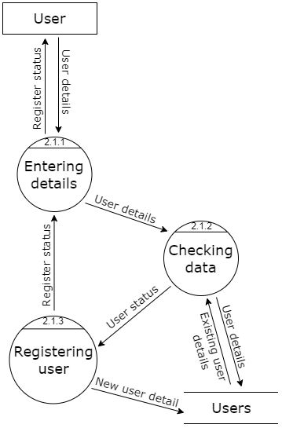

**Figure 6.1.2:- level 2 DFD**

**6.1. 3** **Dataflow diagram**

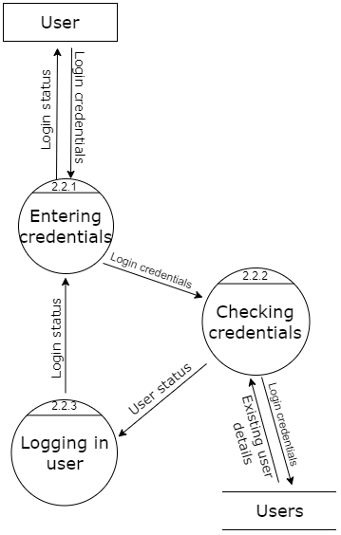

**Figure 6.1.3:- level 2 DFD**

# 7. Requirement document

The Leo Futsal system is an online booking system aimed at facilitating the reservation of futsal courts. The system is designed to provide a convenient way for customers to book futsal fields and for administrators to manage bookings efficiently.A requirement document, often known as a Software Requirements Specification (SRS), details the functionality and constraints of a project. It serves as a foundation for all future project development and testing activities. The purpose of this document is to outline the requirements for the development of the Leo Futsal system. It aims to serve as a reference for the development team, ensuring all necessary functionalities are included.

The scope of the Leo Futsal system includes:

* User registration and management
* Futsal court booking and scheduling
* Payment processing
* Administrative management of bookings
* Real-time updates on court availability

**Functional Requirements:**

| **D** | **Requirement Description** | **Priority** |
| --- | --- | --- |
| FR01 | User Registration: Users must be able to register with the system. | High |
| FR02 | User Login: Registered users must be able to log in to the system. | High |
| FR03 | Court Booking: Users must be able to book futsal courts. | High |
| FR04 | View Availability: Users must be able to view court availability. | High |
| FR05 | Payment Processing: Users must be able to make payments online. | Medium |
| FR06 | Admin Dashboard: Admins must have access to a dashboard for managing bookings and users. | High |
| FR07 | Notifications: Users must receive booking confirmations via email/SMS. | Medium |
| FR08 | User Profile Management: Users must be able to update their profiles. | Medium |

**Non-Functional Requirements**

| **ID** | **Requirement Description** | **Priority** |
| --- | --- | --- |
| NFR01 | Performance: The system should handle 1000 concurrent users. | High |
| NFR02 | Security: User data should be encrypted and securely stored. | High |
| NFR03 | Usability: The system should be user-friendly and easy to navigate. | High |
| NFR04 | Reliability: The system should have an uptime of 99.9%. | High |
| NFRO5 | Scalability: The system should be scalable to accommodate more users and futsal courts. | Medium |

# 8.testing

Testing methodology is the various strategy or approaches used to test and application to ensure it behaves and looks as expected.the method or approaches to testing that include unit testing through system testing.It also include testing lifecycle.

* Requirement Analysis − SRD is ready and shared with the stakeholders, the
* testing team starts high level analysis concerning the AUT (Application under
* Test).
* Test Planning or Execution− Test Team plans the strategy and approach, can be forward testing, backward testing, concurrent testing, modular testing.
* Test Case Designing − create the test cases based on scope and criteria.
* Test Environment Setup − When integrated environment is ready to validate
* the product.
* Test Execution − Real-time validation of product and finding bugs.
* Test Closure − Once testing is completed, matrix, reports, results are document

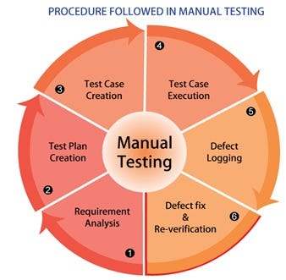

|  |  |  |  |  |
| --- | --- | --- | --- | --- |
| Test Case ID | Test Case | Test Steps | Test Data | Results |
| TC001 | Verify website interface | 1. Open the browser   Enter the URL: localhost/project02 | - | The website interface loads successfully. |
| TC002 | Admin login  & logout | 1. Open the browser 2. Enter the URL: localhost/project02/admin 3. Click on the login button 4. Enter username and password   **logout**   1. Login as an admin 2. Click on the profile icon   Select the "Logout" option | Admin  username  and password | The admin is successfully  The admin is successfully logged out.logged in. |
| TC003 | Admin register | 1. Open browser and enter URL: localhost/project02/admin 2. Click on register button 3. Enter username , password 4. Click register button | Username:  Admin  Password;  admin | Admin login successfull |
| TC004 | Add product | 1. Login to admin panel 2. Go to product 3. Enter product name ,price, 3 photos and description 4. Click add product button | Product name: monitor  Price:25000  3 photos  Description :asdfgh | add  successfully |
| TC005 | View completed and pending orders | 1).login to admin panel  2). Click on pending and completed order simultaneouslt |  | Display successfully |
| TC006 | Register new account | 1. Open the browser and type URL:localhost/project02 2. Press the user icon 3. Click on register order 4. Insert username, email , password | Username:anish  Email:anish@anish.com  Password:anish  Conform password:  anish | Register successful |
| TC007 | Add producr to cart | After login   1. Select product and add add to cart button |  | Add to cart succrssfull. |
| TC008 | Proceed to checkout from cart | After TC007  1.update quantity as need  2. delete unwanted or additional product.  3.proceed to checkout  4.Fill the necessary details  5. press place order button |  | Place order successful |
| TC009 | Send message to admin | 1. After login go to contact page 2. Fill the required details 3. Send message button | Name :khanal  Email:khanal@khanal  Number:1234567895  Message: face issue | Send message successfull |

# 9.PROJECT RESULT

The best project results of the "Leo-Futsal" management system after the project demo include:

* User-Friendly Interface: The system provided a user-friendly interface that made it easy for customers to book futsal courts online. This feature significantly reduced booking conflicts and double bookings by ensuring real-time updates on court availability.
* Real-Time Updates: The system ensured users had accurate information to make well-informed booking selections by providing up-to-date information about court availability.
* Robust Backend System: Developed using Laravel, the backend architecture effectively managed user reservations, court availability, and vendor interactions, providing a dependable system for both users and administrators.
* Data Security and Integrity: The transition from manual to digital booking has enhanced the security and integrity of customer data, reducing the risk of data loss or misplacement.
* Improved Data Management: By transitioning from manual data entry to an automated system, the project ensured the secure storage and easy retrieval of booking records and customer information. This enhances data integrity and accessibility.
* Enhanced User Experience: The development of a dynamic mobile app using Flutter prioritized a seamless user experience, making it easy for users to navigate the app and book futsal courts conveniently from their mobile device
* Future Enhancements: The project outlines potential future enhancements such as the integration of advanced analytics, AI-driven match prediction, and performance analysis. These features can help teams and coaches make data-driven decisions and improve overall performance

# 10.Future enhancement

# As the Futsal Management System evolves, several future enhancements can be integrated to further improve its functionality and user experience. One potential enhancement is the implementation of advanced analytics and machine learning algorithms to provide recommendations for player development and team strategies. Integrating AI-driven match prediction and performance analysis can help teams and coaches make data-driven decisions. Additionally, expanding the system to include a robust mobile app with real-time notifications and GPS-based venue directions will enhance accessibility and convenience for users.

# Furthermore, incorporating social features such as player profiles, match highlights, and social media integration can foster a community around the sport, encouraging engagement and participation. Another significant enhancement could involve developing a comprehensive league management module that supports tournament scheduling, live scoring, and automated bracket generation. Integrating with wearable fitness trackers and smart equipment could also offer personalized training programs and injury prevention tips. Lastly, expanding payment options to include cryptocurrencies and digital wallets, as well as offering multi-language support, will cater to a broader, more diverse user base. These enhancements will ensure that the Futsal Management System remains at the forefront of technological innovation, providing an unparalleled experience for all users.

* Analytics Integration: Provide detailed reports and analytics for court usage.
* AI Recommendations: Suggest optimal booking times based on user preferences.
* Enhanced Security Features: Implement multi-factor authentication for users.
* Mobile App Features: Add push notifications and location-based services.

# 11.CONCLUSION

In conclusion, The development and implementation of ‘Leo Futsal mark a significant advancement in the efficient and effective management of futsal activities. By addressing critical issues such as scheduling conflicts, player and team management, venue utilization, and communication challenges, the system provides a comprehensive solution that streamlines operations for players, coaches, venue managers, and other stakeholders. The integration of automated processes, real-time data access, and user-friendly interfaces significantly enhances the overall experience and ensures smooth coordination of futsal events.

Looking forward, the system's potential for future enhancements, such as advanced analytics, mobile app features, and social media integration, promises to keep it relevant and valuable in an ever-evolving sports environment. The Futsal Management System not only simplifies administrative tasks but also fosters a more connected and engaged futsal community, contributing to the sport's growth and popularity. By leveraging technology to overcome traditional management hurdles, this project sets a new standard for sports management systems, paving the way for more innovative solutions in the future.

# 12. REFRENCES

* ChatGPT - OpenAI:https://openai.com/research/chatgpt/
* FIFA (2007). Big Count 2006: Statistical Summary Report, FIFA Communications Division, 2007. [Online]. Available: http://www.fifa.com/mm/document/fifafacts/bcoffsurv/bigcount.su mmaryreport_7022.pdf. [Last accessed Jan. 27 2014].
* Football Federation Australia (2009). National Football Development Plan. [Online]. Available http://www.klufc.org.au/publications/ffa-national-footballdevelopment-plan. [Last accessed Jan. 25 2014]; Cited by Australia Soccer International, Jul/Aug 2009, 17 Issue 7, p68.
* Shafiee S, Rostami H, Mamashloo H, Deh Panah S. SWOT Analysis of Golestan Province's Football and Delivering Suitable Strategies. Sport Dev Manage. 2017;6(2):119-140.
* Abrahamsson, P., Salo, O., Ronkainen, J., & Warsta, J. (2017, September 25). Agile software development methods: Review and analysis. arXiv (arXiv:1709.08439). Retrieved from <https://arxiv.org/abs/1709.08439>
* , D., & Grant, T. (with Gerush, M. & D’silva, D.). (2010). Agile development: Mainstream adoption has changed agility. Forrester Research, 2(1), 41. Retrieved from <https://www.forrester.com/go?objectid=RES56100>

# 13.ANNEX